**ST.XAVIER’S COLLEGE**

MAITIGHAR, KATHMANDU



**Computer Graphics Assignment #8**

**Reflection through X and Y Axis**

**Submitted By:**

Binod Marikhu

013BScCSIT013

**Submitted to:**

|  |  |
| --- | --- |
| Er. Anil K. Sah  Lecturer, Department of Computer Science |  |

**Submission on: August 25, 2015**

**STATEMENT**

Reflect an object through X-axis and Y-axis

**SOURCE CODE**

//---------------------------------------------------------------------------

#include <vcl\vcl.h>

#pragma hdrstop

#include "Reflection.h"

//---------------------------------------------------------------------------

#pragma resource "*.dfm"

TForm1 *Form1;

//---------------------------------------------------------------------------

__fastcall TForm1::TForm1(TComponent* Owner)

: TForm(Owner)

{

}

//---------------------------------------------------------------------------

void __fastcall TForm1::XAxixClick(TObject *Sender)

{

//Reflection axis for x-axis

int y=(ReflectionY->Height);

for (int i=(Source->Height); i>=0; i--){

for (int j=(Source->Width); j>=0; j--){

ReflectionY->Canvas->Pixels[i][y-j]=Source->Canvas->Pixels[i][j];

}

}

}

//---------------------------------------------------------------------------

void __fastcall TForm1::YAxixClick(TObject *Sender)

{

//Refelction axis for Y-axis

int x=(ReflectionX->Width);

for (int i=(Source->Height); i>=0; i--){

for (int j=(Source->Width); j>=0; j--){

ReflectionX->Canvas->Pixels[x-i][j]=Source->Canvas->Pixels[i][j];

}

}

}

//---------------------------------------------------------------------------

**OUTPUT**

1. **Reflection through Y-axis**

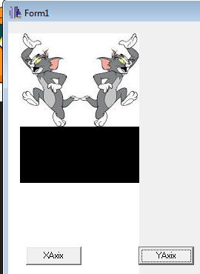

1. **Reflection through X-axis**

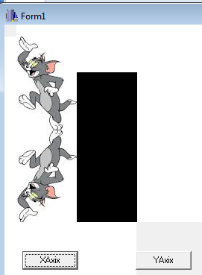

**CONCLUSION**

Hence, an image was reflected through x-axis and y-axis in C++ builder.